WEEKLY REPORT 1
Week: 08/10 - 11/10

1. Member 1
Fullname: Nguyễn Thị Tuyết Minh.
MSSV: 24127451.

1.1. Done Tasks

Task 1: PA0: Synthesize, check, and finalize PA0.

Task 2: Tool Setup: Set up GitHub and Jira.

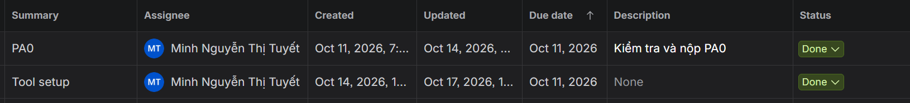

1.2. To Do Tasks

Task 1: Weekly Report 1.
- Task 2: Weekly Report 2.
- Task 3: Rup_sdpln: Implement sections 3 and 4 of the project plan.
- Task 4: PA1: Synthesize, check, and finalize PA0.

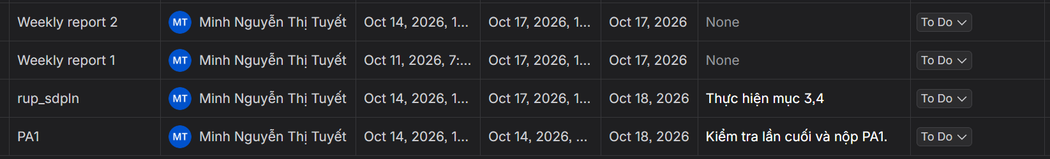

1.3. Issues
No significant issues this week.

2. Member 2
Fullname: Dương Phan Thiên Tú.
MSSV: 24127141.

2.1. Done Tasks
- Task 1: Interview potential users.

2.2. To Do Tasks
- Task 1: Rup_sdpln: Implement sections 1 and 2 of the project plan.
- Task 2: Rup_vision: Implement sections 1, 2, and 3 of the vision document.

2.3. Issues
No significant issues this week.

3. Member 3
Fullname: Phạm Phong Vĩ.
MSSV: 24127588.

3.1. Done Tasks
- Task 1: Interview potential users.

3.2. To Do Tasks
- Task 1: UI prototyping: Create preliminary UI designs for the system.
- Task 2: Rup_vision: Implement sections 4, 5, and 6 of the vision document.

3.3. Issues
No significant issues this week.

